4. FLUID KINEMATICS
FLUID KINEMATICS: Study of the fluid flow without considering the forces causing the flow.
APPROACHES
LAGRANGIAN APPROACH | EULERIAN APPROACH
Partial Oriented Approach | Position Oriented Approach
$$\vec{S }=f\left(\vec{S_{0}},t\right)$$  $Where,\vec{S }=$ Identity of Partial,  $\vec{S_{0}}=$ Initial Identity of Partial | $$\vec{S }=f\left(\vec{P },t\right)$$  $Where,\vec{S }=$ Identity of Partial,  $\vec{P }=$ Position Vector or Space Coordinates
Conservations Laws are applied to partials | Conservations Laws are applied to Control volume
It’s system approach | It’s Control volume approach
 | Most Commonly used due to simplicity of analysis.
VELOCITY: Time rate of change of displacement. It’s vector quantity.
Velocity in Cartesian Co-Ordinate System$\left(x,y,z\right)$,  $$\vec{V }=u\hat{i}+v\hat{j}+w\hat{k}=f\left(x,y,z,t\right)$$  $$u=\frac{dx}{dt}= f_{1}\left(x,y,z,t\right)$$  $$v=\frac{dy}{dt}= f_{2}\left(x,y,z,t\right)$$  $$w=\frac{dz}{dt}= f_{3}\left(x,y,z,t\right)$$ | Velocity in Cylindrical Polar Co-Ordinate System$\left(r,θ,z\right)$,  $$\vec{V }=V_{r}\hat{i}+V_{θ}\hat{j}+V_{z}\hat{k}=f\left(r,θ,z,t\right)$$  $$V_{r}=\frac{dr}{dt}= f_{1}\left(r,θ,z,t\right)$$  $$V_{θ}=r\frac{dθ}{dt}= f_{2}\left(r,θ,z,t\right)$$  $$V_{z}=\frac{dz}{dt}= f_{3}\left(r,θ,z,t\right)$$

CLASSIFICATION OF FLOW
STEADY FLOW | UNIFORM FLOW
It’s Flow in which velocity and other hydrodynamic parameters don’t fluctuate w. r. t. time. $\vec{V }≠f\left(t\right)$ | It’s Flow in which velocity doesn’t fluctuate or change w. r. t. Space.$\vec{V }≠f\left(x,y,z\right)$
VISCOUS FLOW | 1D, 2D, 3D
It’s Flow in which Newtons Law is valid. It’s non uniform flow. Because $u=f(y)({du}/{dy} term)$ | It’s Flow in which Flow is function of No. of Space Parameters.
MASS FLOW RATE ($\dot{m }$): Amount of mass crossing a section per unit time.
$$\dot{m }=ρAV, Where V=Avg. Velocity of flow through the cross section$$
VOLUME FLOW RATE/ DISCHARGE ($Q$): Amount of volume crossing a section per unit time.
$$Q=AV={\dot{m }}/ρ, Where V=Avg. Velocity of flow through the cross section$$
CONTINUITY EQUATION: The result of law of conservation of mass in a fluid flow is continuity equation.
Continuity equation in cartesian co-ordinate system:$∇∙\left(ρ \vec{V }\right)+\dot{ρ}=0$
For Steady flow in cartesian co-ordinate system: $∇∙\left(ρ \vec{V }\right)=0$ | For Incompressible $∇∙\vec{V }=0$
CONSERVATION OF MASS: ${\dot{m}}_{in}-{\dot{m}}_{out}={\dot{m}}_{gen}$
$${\dot{m}}_{in}={\dot{m}}_{out}⇒{\left(ρAV\right)}_{in}={\left(ρAV\right)}_{out} \left(∵Neither mass generation nor mass consumtion\right)$$
ACCELERATION: Time rate of change of velocity.
Velocity in Cartesian Co-Ordinate System$\left(x,y,z\right)$,  $$\vec{a }=a_{x}\hat{i}+a_{y}\hat{j}+a_{z}\hat{k}=g\left(x,y,z,t\right)$$  $$a_{x}=\frac{du}{dt}= g_{1}\left(x,y,z,t\right)$$  $$a_{y}=\frac{dv}{dt}= g_{2}\left(x,y,z,t\right)$$  $$a_{z}=\frac{dw}{dt}= g_{3}\left(x,y,z,t\right)$$ | Velocity in Cylindrical Polar Co-Ordinate System$\left(r,θ,z\right)$,  $$\vec{V }=a_{r}\hat{i}+a_{θ}\hat{j}+a_{z}\hat{k}=g\left(r,θ,z,t\right)$$  $$a_{r}=\frac{dV_{r}}{dt}= g_{1}\left(r,θ,z,t\right)$$  $$a_{θ}=r\frac{dV_{θ}}{dt}= g_{2}\left(r,θ,z,t\right)$$  $$a_{z}=\frac{dV_{z}}{dt}= g_{3}\left(r,θ,z,t\right)$$
$$du={\left(δu\right)}_{x}+{\left(δu\right)}_{y}+{\left(δu\right)}_{z}+{\left(δu\right)}_{t}=\frac{∂u}{∂x}dx+\frac{∂u}{∂y}dy+\frac{∂u}{∂z}dz+\frac{∂u}{∂t}dt⇒\frac{du}{dt}=\frac{∂u}{∂x}\frac{dx}{dt}+\frac{∂u}{∂y}\frac{dy}{dt}+\frac{∂u}{∂z}\frac{dz}{dt}+\frac{∂u}{∂t}\frac{dt}{dt}$$
$$a_{x}=u\frac{∂u}{∂x}+v\frac{∂u}{∂y}+w\frac{∂u}{∂z}+\frac{∂u}{∂t}$$ | $$a_{y}=u\frac{∂v}{∂x}+v\frac{∂v}{∂y}+w\frac{∂v}{∂z}+\frac{∂v}{∂t}$$ | $$a_{z}=u\frac{∂w}{∂x}+v\frac{∂w}{∂y}+w\frac{∂w}{∂z}+\frac{∂w}{∂t}$$
MATERIAL DERIVATIVE: ${DM}/{Dt}=\left(\vec{V }∙∇\right) M+\dot{M}$
Local/ Temporal Change Terms: $\dot{M}$ | Convective Change Terms: $\left(\vec{V }∙∇\right) M$

$$a_{r}=V_{r}\frac{∂V_{r}}{∂r}+\frac{V_{θ}}{r}\frac{∂V_{r}}{∂θ}+V_{z}\frac{∂V_{r}}{∂z}+\frac{∂V_{r}}{∂t}-\frac{V_{θ}^{2}}{r}(Centri.)$$ | $$a_{θ}=V_{r}\frac{∂V_{θ}}{∂r}+\frac{V_{θ}}{r}\frac{∂V_{θ}}{∂θ}+V_{z}\frac{∂V_{θ}}{∂z}+\frac{∂V_{θ}}{∂t}-\frac{V_{θ}V_{r}}{r}(Coriolli.)$$ | $$a_{z}=V_{r}\frac{∂V_{z}}{∂r}+\frac{V_{θ}}{r}\frac{∂V_{z}}{∂θ}+V_{z}\frac{∂V_{z}}{∂z}+\frac{∂V_{z}}{∂t}$$

STREAM LINE: A set of imaginary curves drawn in a flow field at given instant of time such that tangent at any point represent the direction of velocity vector for the same position.  STREAM TUBE: A bundle of stream line forming a passage through which flow can be visualized. | 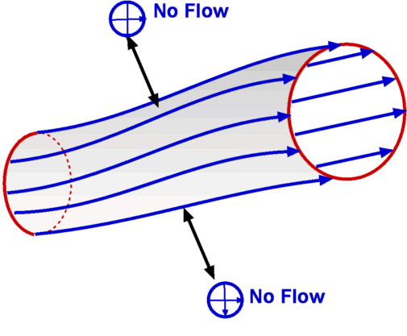
PROPERTIES OF STREAMLINES AND STREAM TUBES:
- The streamlines cannot intersect each other nor can a streamline interest itself.
- Flow is possible only along the stream line. It’s impossible across stream line.
- In Steady flow streamlines don’t fluctuate w. r. t. time.
EQUATION OF STREAM LINES:  $$\vec{V }×d\vec{S }=0 (Because Both are in same direction)$$ | $$∴\frac{dx}{u}=\frac{dy}{v}=\frac{dz}{w}$$
$$Slope of stream line = Slope of velocity vector$$
ACCELERATIONS W.R.T. STREAM LINES: There are two mutually perpendicular accelerations developed,
- Tangential Acceleration ($a_{s}$)  - Normal Acceleration ($a_{n}$) | $$a=\sqrt{a_{s}^{2}+a_{n}^{2}}$$ | $$a_{s}=\frac{∂V_{s}}{∂t}+V_{s}\frac{∂V_{s}}{∂s}$$ | $$a_{n}=\frac{∂V_{n}}{∂t}+V_{s}\frac{V_{s}^{2}}{r}$$
PATH LINE: The path travelled by a particular particle (Lagrangian Approach) in a flow field over a period of time.
PROPERTIES OF PATH LINES:
- The Path lines can be intersected each other and it can interest itself but only in unsteady flow.
- In Steady flow Path lines don’t fluctuate w. r. t. time and $Path lines = Stream lines.$
STREAK LINES: It’s instantaneous line obtained by joining position of different fluid particles which have sequentially passed thorough same point in the flow. E.g. Die injected in the flow.  - A Family of streak lines drawn in the flow field is known as Rake of Streak lines.  - In Steady Flow Streak lines don’t fluctuate w. r. t. time and  $$Streak lines = Stream lines=Path lines (For Stready Flow)$$ | 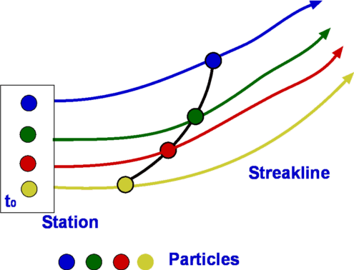
TIMELINE: A set of curves drawn in a flow field which represent the positions of a set of neighbouring particles at which various instance of times. E.g. hydrogen bubbles forming velocity profiles.
- Timelines help in understanding the uniformity or non-uniformity of a flow.
DEFORMATIONS & ROTATIONS:
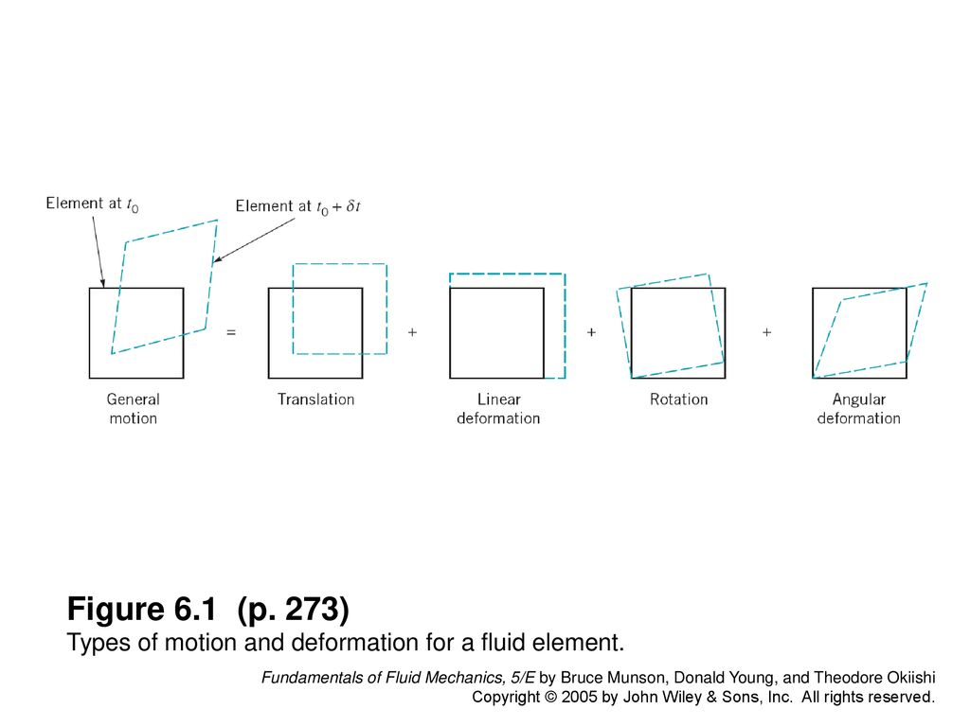
Linear Deformation |  |  | Angular Deformation
$${\dot{ε}}_{k}=\frac{∂V_{k}}{∂k}$$ |  |  | $$Avg. Rate:\frac{{\dot{γ}}_{mn}}{2}=\frac{1}{2}\left(\frac{∂V_{n}}{∂m}+\frac{∂V_{m}}{∂n}\right)$$ | $$Tot. Rate:{\dot{ε}}_{mn}={\dot{γ}}_{mn}$$
Rotational Deformation |  |  | Rotation
$$\dot{θ}=\frac{∂v}{∂x}$$ | $$\dot{∅}=-\frac{∂u}{∂y}$$ | $$ω_{z}=\frac{1}{2}\left(\dot{θ}+\dot{∅}\right)$$ | It’s the arethematic mean of angular velocities of two mutually perpendicular line segments in a fluid element. It’s vector quatity and given by half of curl of velocity vector.  $$\vec{ω }=\left(1/2\right)\left(∇×\vec{V }\right)$$
Shear Stress
$$τ_{mn}=μ{\dot{ε}}_{mn}$$
VORTICITY ($\vec{ξ }$) : It’s curl of velocity Vector. $\vec{ξ }(in {rad}/s)=2 \vec{ω }=∇×\vec{V }$

CIRCULATION ($Γ$): The line integral of tangential component of velocity taken across a closed contour is known as circulation. | $$Γ=\oint{\vec{V }∙d\vec{S }}=\iint{\vec{ξ }∙d\vec{A }}$$
NOTE: Intensity of circulation per unit area is known as vorticity.
CLASSIFICATION OF FLOW BASED ON ROTATION
ROTATIONAL FLOW | IRROTATIONAL FLOW
A Flow in which Fluid Element rotates about it’s mass centre. | A Flow in which Fluid Element doesn’t rotates about it’s mass centre.
$$\vec{ξ }≠0$$ | $$\vec{ξ }=Γ=\vec{ω }=0$$
Flux P of Q is defined as $P=\iint{\vec{Q }}∙d\vec{A }$
STREAM FUNCTION ($ψ$):
A function defined in a 2D Flow field such that it takes a constant value along a particular stream line.
$$For Given Stream Line, dψ=0 \& u=-\frac{∂ψ}{∂y}, v=\frac{∂ψ}{∂x}$$ | $$\left|∆ψ\right|=q=Q/{width}$$ | Note: Sign is not an issue.
- The difference in stream function gives the discharge per unit width between corresponding stream lines.
- Discharge per unit width across any section between two given stream lines is a constant.
POTENTIAL FUNCTION ($∅$): $\vec{ξ }=∇×\vec{V }=\vec{0 }(Irrotational Flow)⇒\vec{V }=∇∙∅ \left(From the Maths Basics\right)$
Irrotational flow is also called as potential flow (From the above equation).
$$∅=f(x,y,z)$$ | $$u=-\frac{∂∅}{∂x}, v=-\frac{∂∅}{∂y},z=-\frac{∂∅}{∂z}$$ | Note: Negative Sign represents that the flow takes place in the direction of decrease in potential. Sign is not an issue.
EQUIPOTENTIAL LINES: A set of curves along which $∅$ takes constant value. $d∅=0$
$$d∅=\frac{∂∅}{∂x}dx+\frac{∂∅}{∂y}+dy=u dx+v dy$$ | $${\left(\frac{dy}{dx}\right)}_{EPL}{\left(\frac{dy}{dx}\right)}_{StreamLine}=-1, {\left(\frac{dy}{dx}\right)}_{EPL}=-\frac{u}{v}$$
- The stream lines and equipotential lines are orthogonal to each other except stagnation point.
FLOWNET: A grid formed by drawing stream lines and equipotential lines is known as flow net.
STAGNATION POINT: The Point in a flow field at which all the components of velocity drop down to zero.
- At the stagnation point velocity is zero. So, we can’t define Slope of equipotential Lines and Slope of stream lines at stagnation point.
LAPLACE EQUATION FOR STREAM FUNCTIONS AND POTENTIAL FUNCTIONS:
$$∇^{2}∅=0$$
Laplace equation (Above Equation) represents possible case of incompressible and irrotational flow.
$$∇^{2}ψ=0$$
Laplace equation (Above Equation) represents possible case of irrotational flow.

